Experimental Setup

Setup for router through winbox to ensure that any device can connect to WIFI via unlimited or limited connections

First through the <https://mikrotik.com/download> this URL to download winbox and save to your computer. Open WinBox by double-clicking it (no installation required) and connect to your router by clicking on the MAC address in the Neighbor tab.

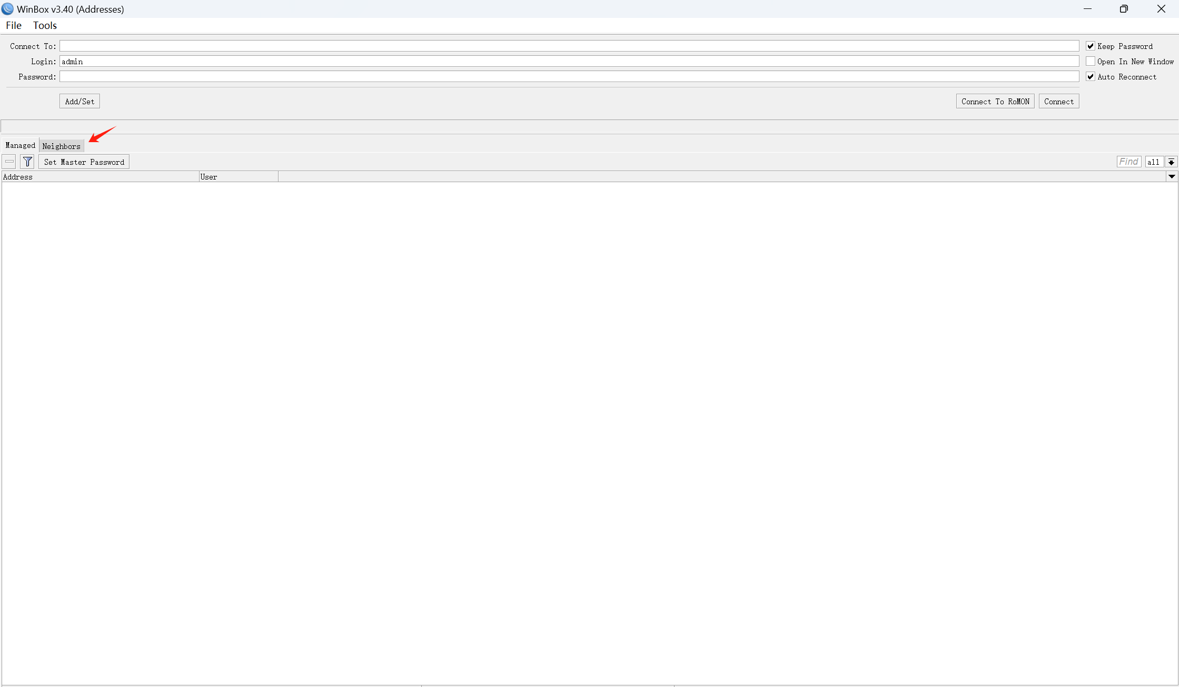

Now you should see the MAC address in the neighbor screen, double click on it and it will connect automatically. Note: The first time you use winbox to log into the router setup, you do not need to enter your password and keep your login name as admin.

需要补一张包含MAC地址的winbox的图，密码要暂时删掉

After a successful connection you should see this page

补一张winbox连接router后的图片

Change password：

Now let's go to system –> password to change the login password for better security. After changing the password, you need to use this login password to login to the router control page. Since we don't have an old password, we just need to enter it in New password and confirm password.

补一张system -》 password， new password和confirm password的图

Bridge：

Go to Bridge and click the plus symbol to create a new bridge, then click OK. This allows us to join the ethernet ports and the WIFI interface/s into our local area network or LAN. By creating bridges, multiple network interfaces, such as wireless and wired interfaces, can be combined into a single unified network segment. As a result, all devices connected to these interfaces will be on the same IP subnet, simplifying network management. Also, after creating a bridge, both wired and wireless devices can communicate with each other within the same network segment. This is useful for scenarios where a wide range of devices need to be managed within the same subnet, such as an enterprise network or home network.

需要一张点击Bridge后添加bridge 那个界面的图。

After creating the bridge, click on the port tab and click on the plus sign to add all the ports into the bridge

添加一张bridge界面port，点击加号后，添加所有端口

IP address and DNS setting：

Give the device an IP address, point it to a public DNS server and allow it to service DNS requests from the LAN:

Next, we’ll give the router an IP address. Go to IP, Addresses, click the plus symbol and type the new IP address and CIDR representing the subnet mask exactly like this 192.168.100.1/24.

Also use the Interface drop-down list and select bridge1. This ensures that the device is accessible by its new IP address through all interfaces listed the bridge1 you created earlier.

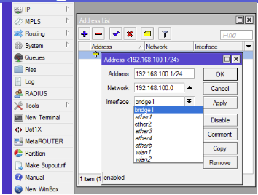

需要重新截图一张自己的

From here on, whenever you want to connect to the router via winbox, click on the IP address instead of the MAC address.

To point the router to a public DNS server go to IP, DNS, click the down arrow to the right of the Servers field and type 8.8.8.8 tick Allow Remote Requests so LAN computers can make DNS requests and click OK.

To point the router to a public DNS server, click IP --> DNS server, complete the setup according to the following figure and click apply. The main role of DNS is to convert human-memorable domain names into machine-readable IP addresses so that computers can communicate with each other. The Server, 8.8.8.8, set up here is one of the public DNS servers provided by Google, which is designed to provide fast, reliable and secure resolution services to users worldwide, so we can use it directly here.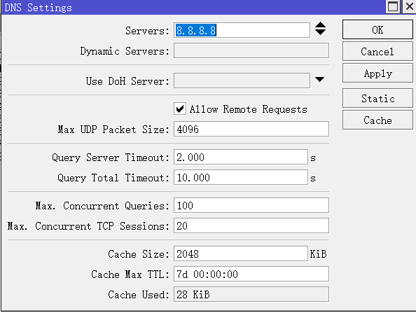

Add a DHCP Server:

Next, we need to create a DHCP server to distribute and manage IP addresses for all devices connected to the router. Click on IP --> DHCP Server --> DHCP --> plus build and set up the DHCP Server as per the screenshot below.

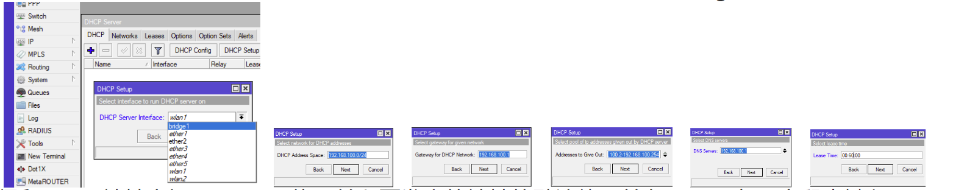

截图DHCP server的设置，一步步来

Set WIFI password and region：

Now let's click on the quick set interface and set the password for our WIFI and set the region for the router.

Quick set的截图，router wifi密码和地区。

If all the above steps are completed, then congratulations, you can use any device to connect to the router and the router will automatically assign IP addresses to them.

You can use ipconfig in windows CMD to view the IP of the current computer, and you can also view what devices are currently connected to the router in winbox.

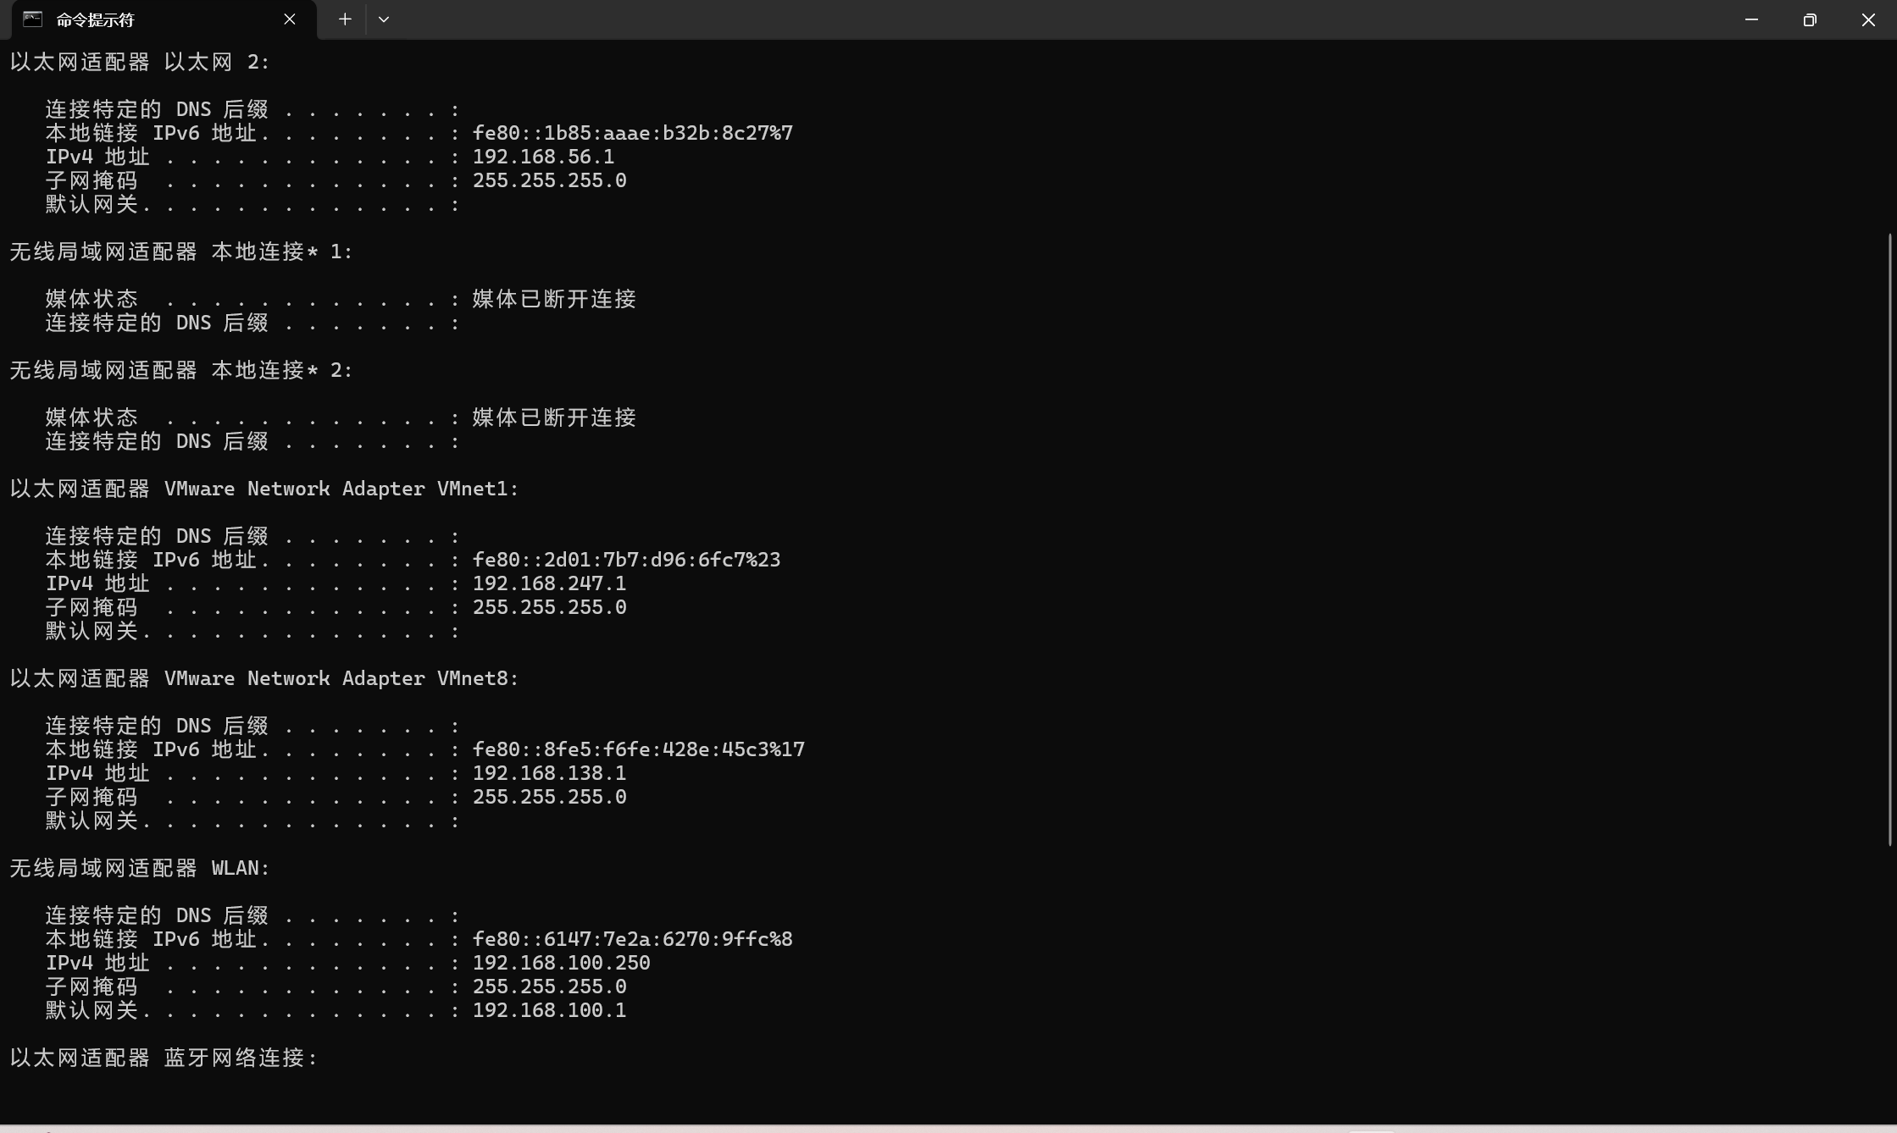

还需要一张winbox包含目前连接设备的图片

Test that the connected device is properly connected to the router and test that data can be transmitted through the router：

The way to test if the device is properly connected to the router and to confirm that data can be transmitted through the router is to use the ping method.

两台电脑互相ping的截图

Next, we will use the windows shared file feature to test if we can transfer data through the router. Make sure both computers are connected to the router and one of them creates a folder and turns on sharing in the settings. The other computer connects to the shared folder by using "Run" and typing "\\ the IP address of the computer sharing the file". If both computers are correctly connected to the router, we can now share files between the two computers through this shared folder to prove that data can be transferred through the router

Windows共享文件夹截图

Virtual Machines:

In this experiment, we will use VMware Pro to run an Ubuntu virtual machine. The exact download address for Ubuntu is https://ubuntu.com/.

After installing the virtual machine, follow these steps to ensure it can communicate properly with the router:

1.Open VMware Pro and select your Ubuntu virtual machine.

2.Click on VM in the top menu and then select Settings.

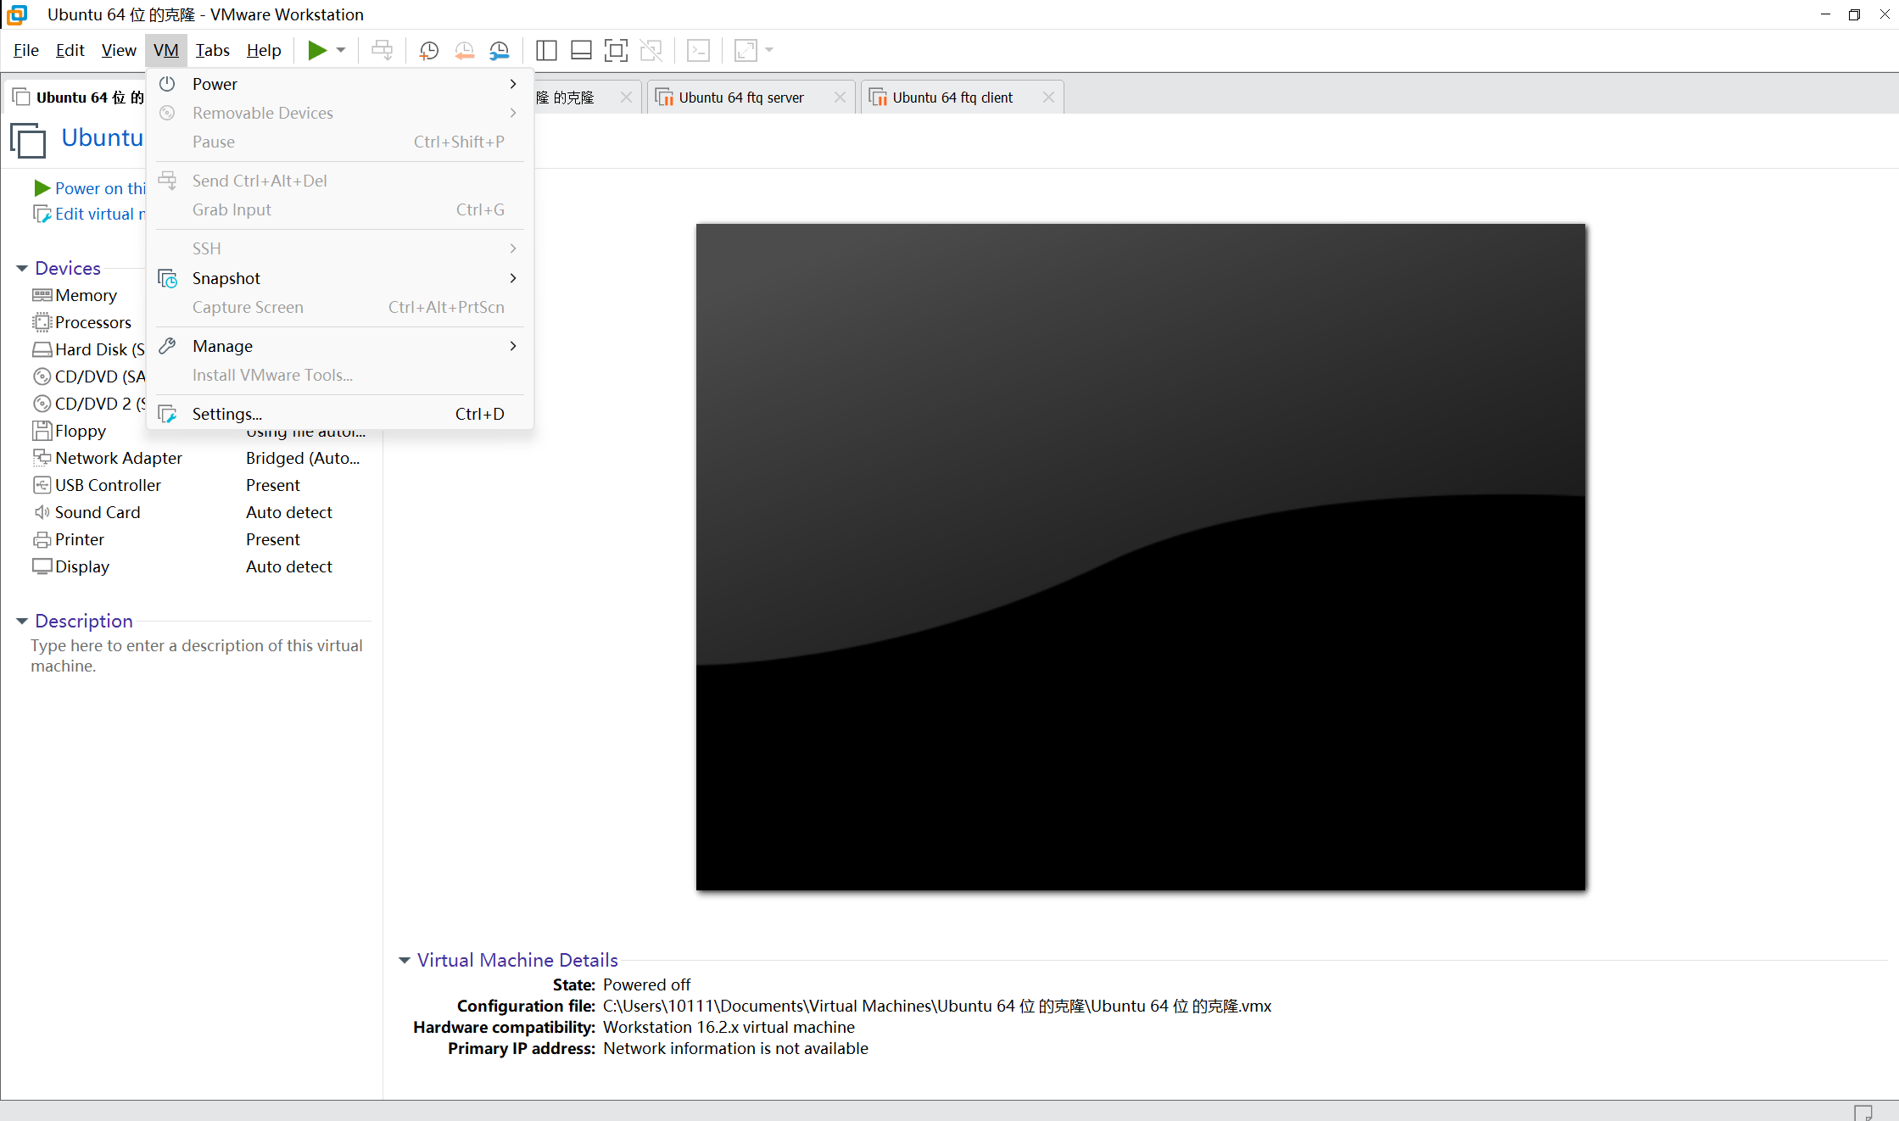

3.In the Settings window, click on Network Adapter.

4.Switch the Network connection to Bridged mode and click on Ok.

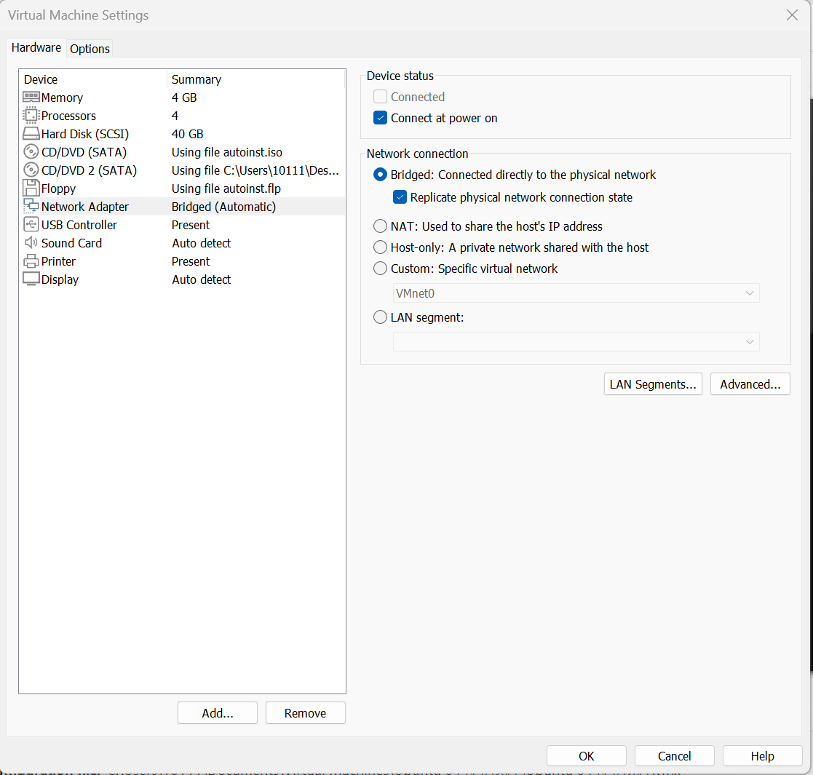

Setting the Network Adapter to Bridged mode is crucial because it allows the virtual machine to appear as a separate device on the network, just like any other physical device. This way, the router can assign the correct IP address to the VM, ensuring it can communicate with other devices on the network and access the internet properly. Without this setting, the VM might not be able to obtain a valid IP address, leading to network connectivity issues.

Now restart the virtual machine, open a terminal and type "sudo apt-get install net-tools" to download the necessary components. After downloading this component, we can check the IP address of the current virtual machine by typing "ifconfig" in the terminal.

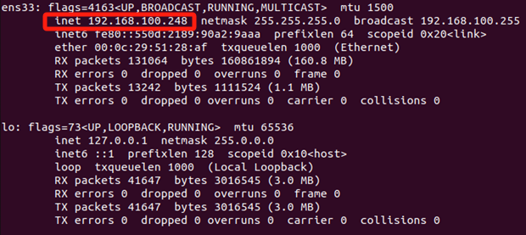

If you wish, you can also test that the VM is correctly connected to the router by pinging it. You can also check that the router is successfully connected to the VM via winbox.

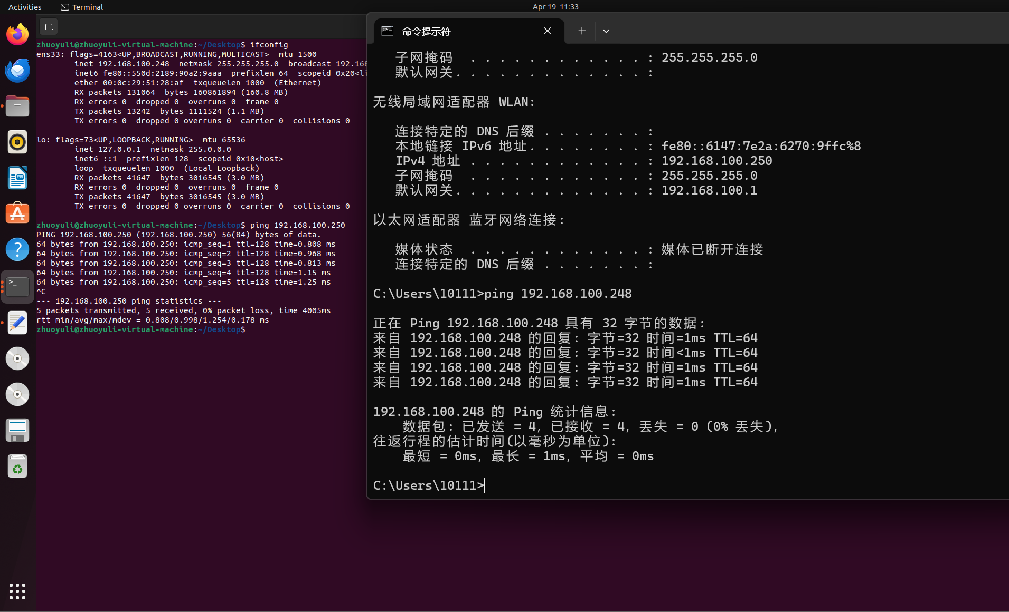

Network Test Tools:

1. Iperf3:

We will use iperf3 as a Network test tool in this research. IPerf3 is a tool for active measurements of the maximum achievable bandwidth on IP networks. It supports tuning of various parameters related to timing, buffers and protocols (TCP, UDP, SCTP with IPv4 and IPv6) [4]. Installing iperf3 in Ubuntu is easy, just type "sudo apt-get install iperf3" in the terminal.

After the installation is complete, enter "iperf3 -s -p [port number]" to start the iperf3 server in the virtual machine.

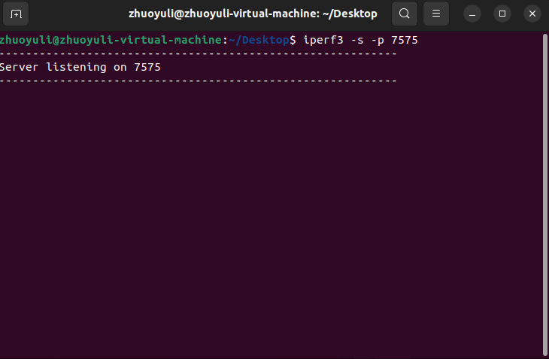

Now turn on another VM and install iperf3, then type "iperf3 -c [server ip address] -p [server port number]” to start the iperf3 client. Note: Make sure that the iperf3 server is on before starting the client. Now iperf3 will automatically check the network performance of the router and generate a report.

需要iperf3 client和server的运行画面，不是tinf模式

The above mode will automatically shut down after running for a certain amount of time, you can specify the number of seconds to run by adding -t after the client's command. For example, "iperf3 -c [server ip address] -p [server port number] -t 300" specifies that iperf3 will run for 300 seconds.

添加 -t 3000的运行画面

If you want iperf3 to network test all the time, just turn -t into -tinf. Command: “iperf3 -c [server ip address] -p [server port number] -tinf”

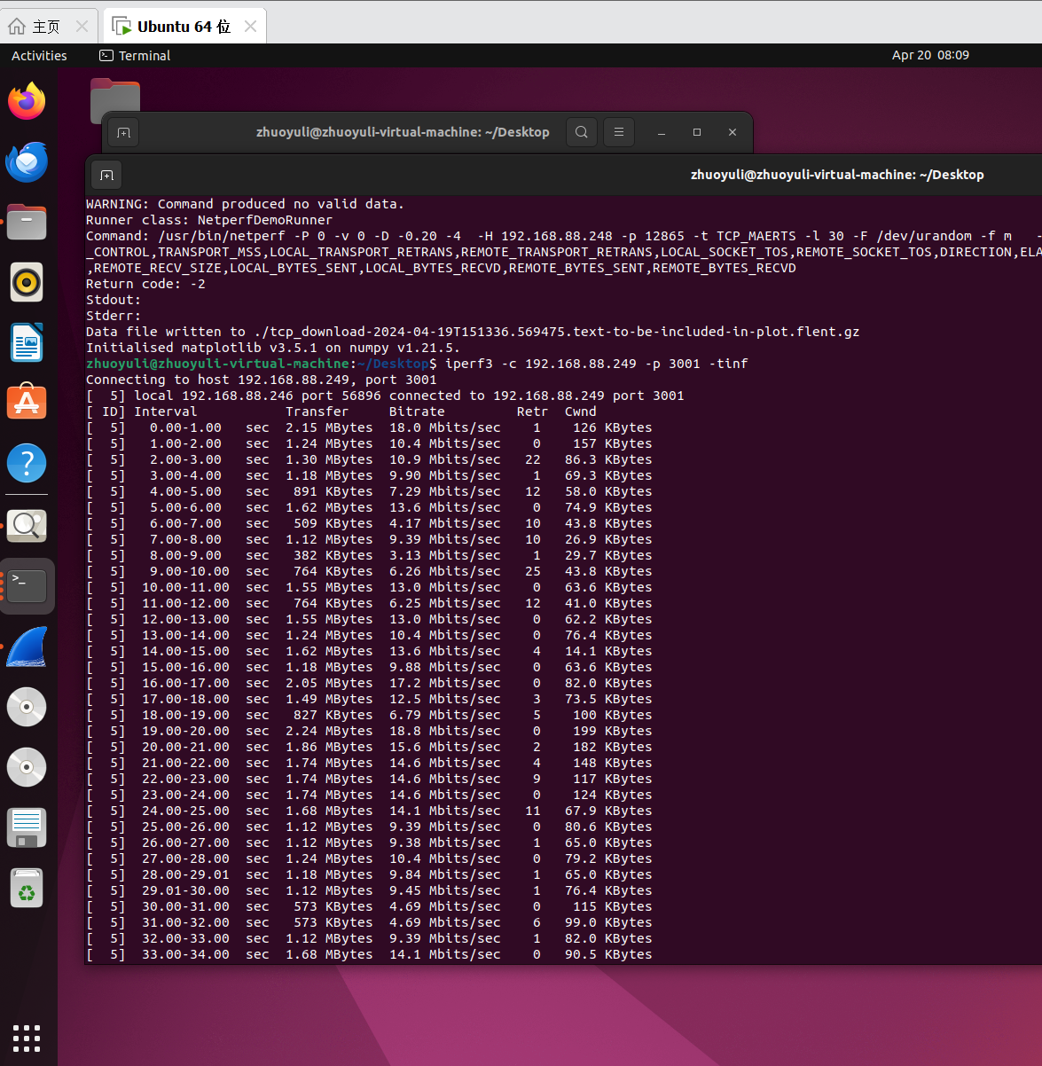

To get more control commands for iperf3 you can check the official user guide: <https://iperf.fr/iperf-doc.php>

1. Flent

Flent (The FLExible Network Tester) is a tool for network performance testing and evaluation. Its main function is to evaluate the performance of a network connection by running a series of network tests and presenting the results in the form of graphs and data reports.Flent is written in Python and supports multiple platforms, running on Linux, Windows and macOS. To install flent we just need to type "sudo apt install flent" in the terminal of the virtual machine. Note: We still need 2 VMs to run flent, make sure you have installed flent in both VMs!

Now start flent in server mode by typing "netserver &" in one of the VM. Unlike iperf3, starting flent in server mode does not take up a terminal, it runs in the background.

Now enter this command in the terminal of VM2 “flent rrul -p all_scaled -l 60 -H address-of-netserver -t text-to-be-included-in-plot -o filename.png”. It will create the standard graphic image used by the Bufferbloat project to show the down/upload speeds plus latency in three separate charts.

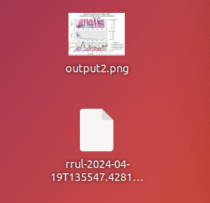

After running the command, it will generate an image and a gz file, double click on the image and you will see the exact details of the image

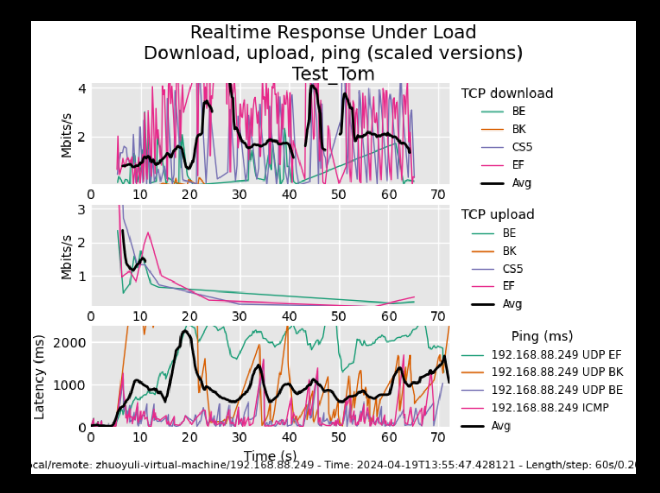

After double-clicking on the gz file, the Flent GUI program will be open, you can see more details and filter the data in the displayed image

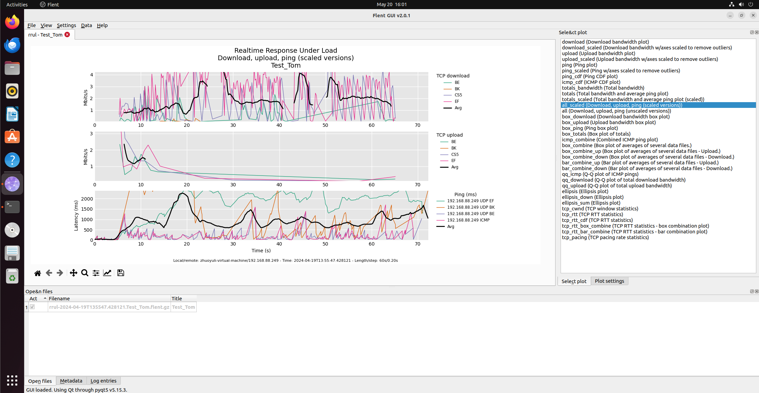

1. Wireshark

Wireshark is a widely used network protocol analysis tool designed to capture and examine network packets. It helps users gain insight into network traffic, diagnose network problems, and analyze network protocol implementations and behavior.

To install wireshark in a virtual machine just type " sudo apt install wireshark" in the terminal.

After the installation is complete, type "wireshark --version" in the terminal to check the version of wireshark, if the following figure appears, it proves that the installation of wireshark is successful.



After opening wireshark, click statistics --> I/O graphs to generate image using the data captured by wireshark.

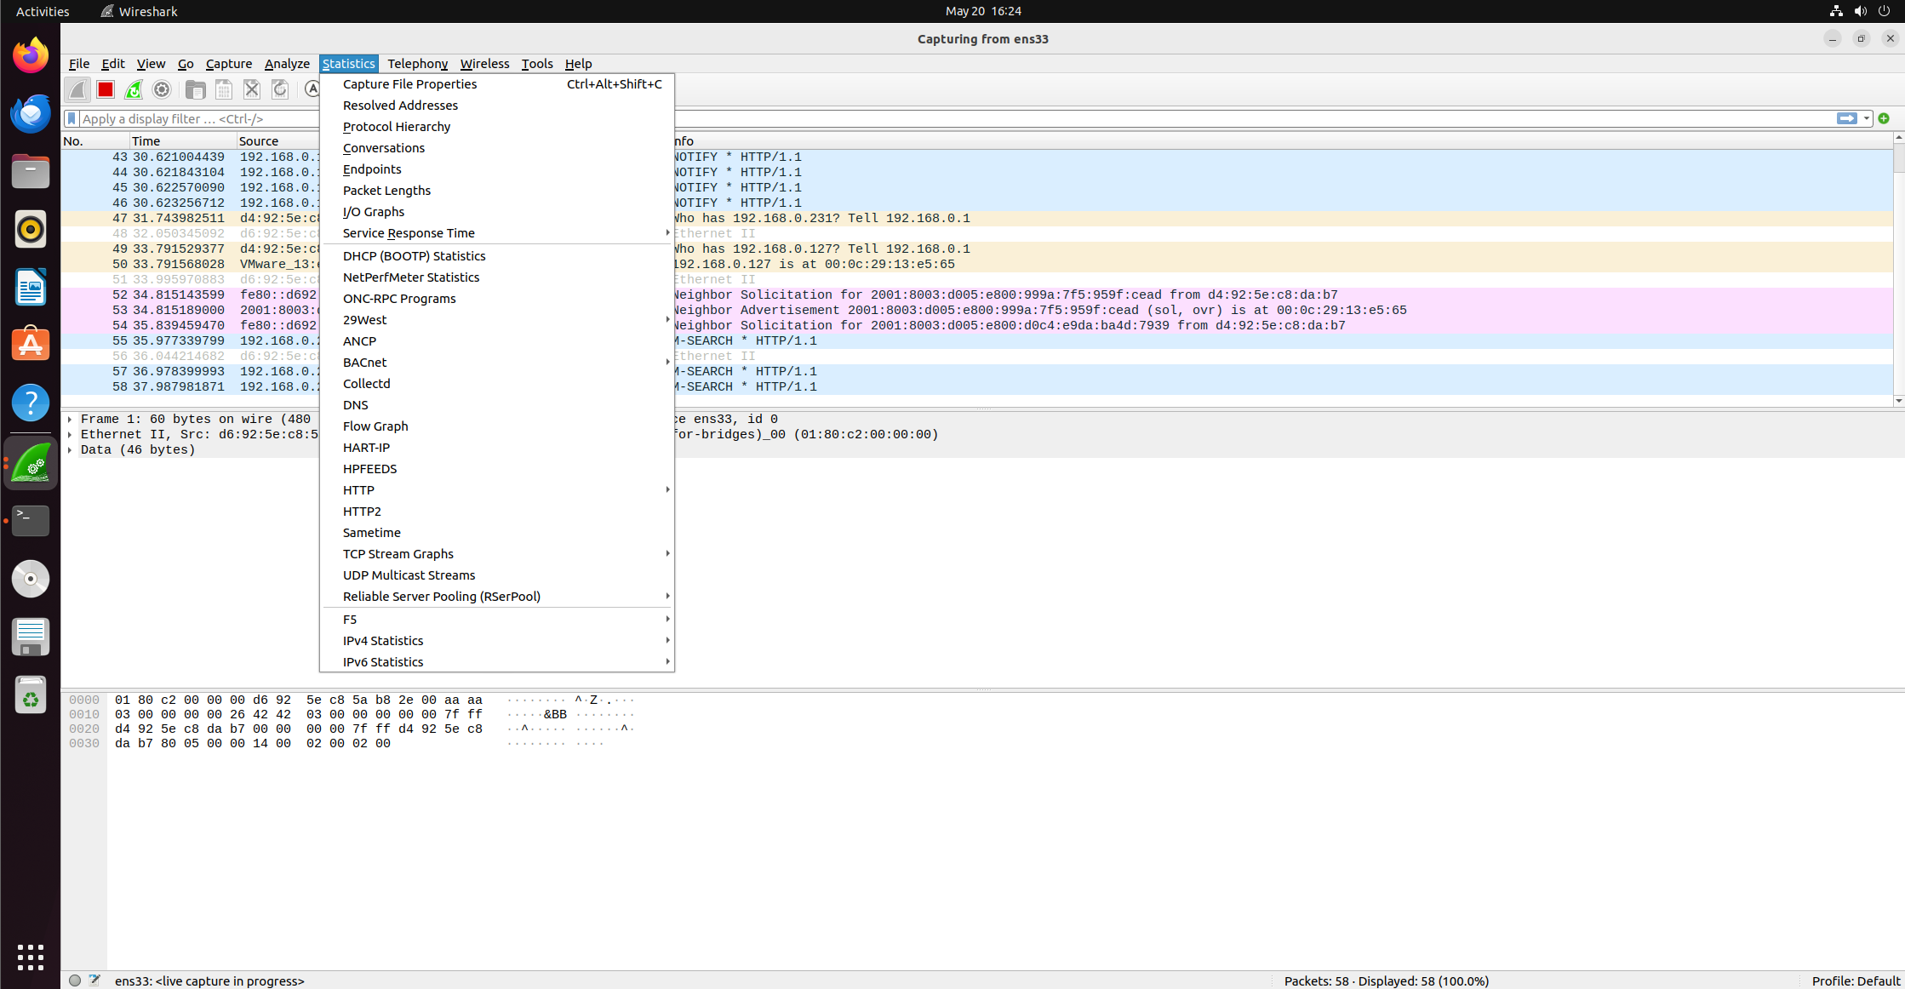

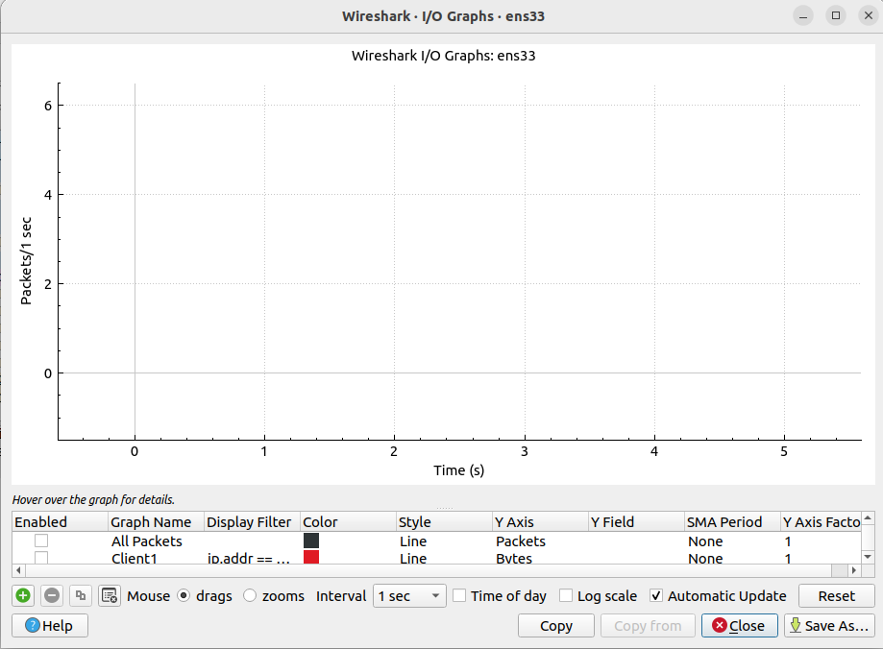

Congestion Control Algorithms：

In this experiment we need to use BBR, Reno, Cubic, BBRv2 and BBRv3. Since linux already comes with Reno and Cubic, we just need to install BBRv2，BBRv3 and turn on BBR.

1. BBR

Although linux comes with BBR, it is not turned on by default, so we need to set it up manually to turn it on.

First, type "sudo nano /etc/sysctl.conf" in the terminal.

Then, Add the following two lines at the end of the file:

net.core.default_qdisc=fq

net.ipv4.tcp_congestion_control=bbr

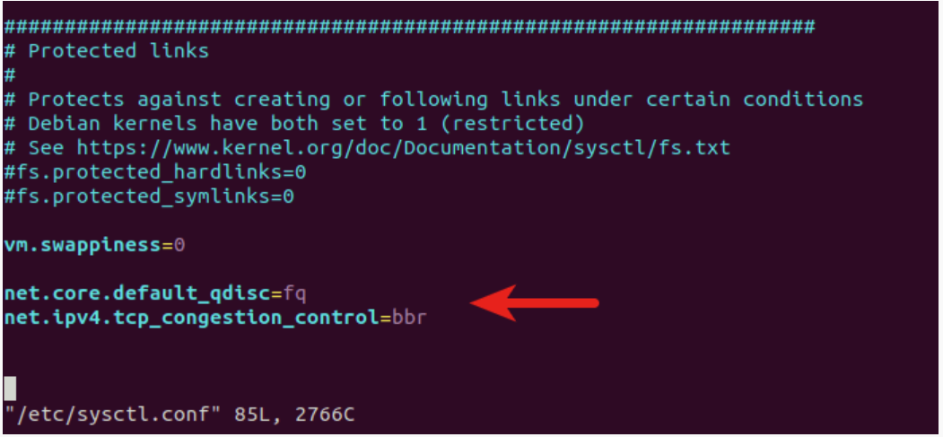

Save and close the file. Then reload sysctl configurations by using this command: “sudo sysctl -p”. You should see this output



Finally, check the congestion control algorithm in use by using this command “sysctl net.ipv4.tcp_congestion_control”. If you see this output that means you have successfully enabled TCP BBR on Ubuntu.



2) BBRv2